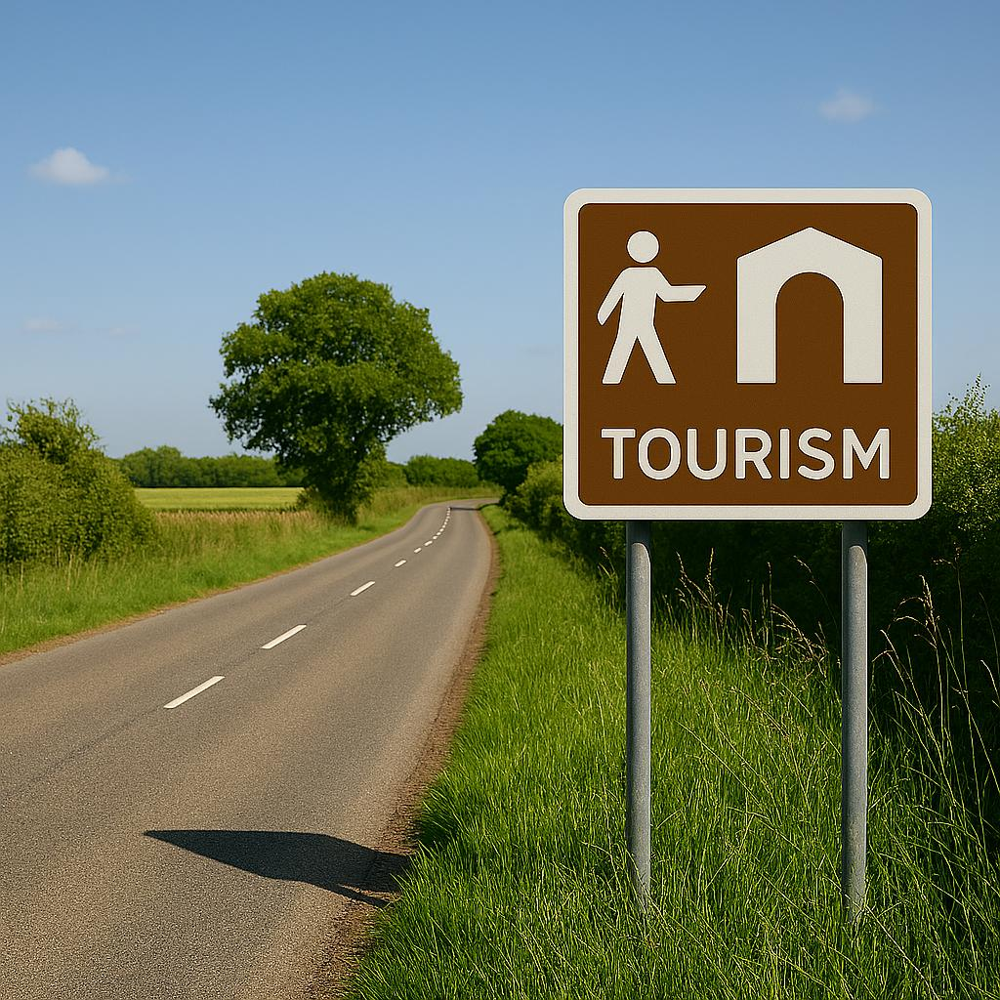

Wiltshire Tourism Signing Policy

Contents Page

Contact Details 3

Introduction 4

Eligibility 6

Guidelines for Signing 9

Costs & Timescale 11

Responsibilities 13

Appendix 1 – Eligibility Criteria 15

Appendix 2 – Application Process 21

Appendix 3 – Designing a Scheme 22

Appendix 4 – Distributor Road in Wiltshire 23

Frequently Asked Question 24

Contact details

All initial enquiries are handled by VisitWiltshire and should be sent to:

davidandrews@visitwiltshire.co.uk
or
info@visitwiltshire.co.uk

For subsequent enquiries relating to Tourism Signs on Wiltshire distributor roads contact:

Wiltshire Council
Highways – Traffic Engineering
Bythesea Road
Trowbridge
Wiltshire
BA14 8JN

Telephone: 0300 456 0100

Email: integrated.transport@wiltshire.gov.uk

For enquiries relating to Tourism Signs on Trunk Roads, which include A36, A303, A419 and M4 contact:

National Highways
Telephone: 03001 235000
Email: info@nationalhighways.co.uk

For enquiries relating to Tourism Signs in the area covered by Swindon Borough Council contact:

Swindon Borough Council
Highways and Transport
Civic Offices
Euclid Street
Swindon
SN1 2JH

Telephone: 01793 445500
Email: traffic_man@swindon.gov.uk

Introduction

1.1 The Department for Transport requires all Highway Authorities to implement its Brown and White Tourism Signs policy, taking into account local circumstances and adhering to the relevant regulations. Wiltshire Council has developed its own Brown and White Tourism Signs policy in collaboration with VisitWiltshire.

1.2 This guide is intended to provide clear guidance on the process for applying for tourism signs within the jurisdiction of Wiltshire Council. It outlines the procedures used to assess the eligibility of attractions and facilities for tourism signage, summarises the application process, and highlights the associated financial responsibilities for applicants.

1.3 There are two principal categories of directional signage permitted on the highway: standard directional signs and tourism signs. Standard directional signs feature blue, green, or white backgrounds, depending on the road classification, and are installed primarily for highway safety and traffic management purposes. Individual businesses are generally not eligible for this type of signage. Tourism signs, distinguished by their brown background, are specifically designed to guide visitors to tourist destinations

1.4 Local leisure facilities may also be signed using brown and white tourism signs. Typically, these include non-commercial venues such as Community Campus Sites or Sports Centres, often operated by the local authority. Signage for such destinations may be provided at the discretion of the Highways Department and may not require adherence to the procedures outlined in this guide

1.5 Applications for tourism signage within Wiltshire are initially reviewed by VisitWiltshire, the Destination Management Organisation for the county. Once preliminary approval is granted, applications are forwarded to Wiltshire Council’s Highways Department. If the proposed signage is to be located on or near a trunk road (A36, A303, A419, or M4), National Highways must also be consulted.

1.6 Applications are subject to a formal assessment process, which includes evaluation against a set of eligibility criteria (see Appendix 1), as well as considerations related to road safety and traffic management (see Appendix 2). While the installation of a sign may appear straightforward, it is important to recognise that factors such as road safety, signage quality, and visual clutter must be carefully considered before approval can be granted

1.7 Tourism signs are not intended for advertising purposes. Their primary function is to assist visitors from outside the local area in locating facilities safely and efficiently. These signs should complement, rather than replicate, existing directional signage.

1.8 Businesses with direct access to the distributor road network (see Appendix 3) will generally not qualify for tourism signage. This determination is made at the discretion of Wiltshire Council’s Traffic Engineering team, which will assess the visibility and recognisability of the site entrance, as well as the potential visual and safety impacts of additional signage at each location

1.9 Applicants should be aware that costs are involved. An initial application fee is required, and if the application is successful, the applicant will be responsible for the costs associated with the design, manufacture, and installation of the signs. Although the signs will remain the property of Wiltshire Council, ongoing maintenance and any future replacement costs will also be borne by the applicant. The total cost for a basic signage scheme is estimated to be approximately £2,500. A successful application typically takes six months to complete.

1.10 Excessive signage can detract from the visual character of an area and may lead to driver confusion. It is therefore essential that the impact of new and additional signage is carefully considered during the application assessment process. Many existing signs were approved under previous, less stringent criteria. Wiltshire is a rural county of considerable charm, and an overabundance of signage risks diminishing its appeal and compromising road safety. To safeguard the interests of both residents and visitors, Wiltshire Council reserves the right to refuse applications—even those that meet eligibility criteria—where it is deemed to be in the broader public interest.

1.11 Consequently, not all eligible applications will be approved, particularly in areas where signage is already prevalent. In such cases, applicants may be encouraged to share tourism signage with other nearby facilities.

Eligibility

2.1 An eligible tourism facility is defined for this purpose as:

"A permanently established attraction or facility of recognised quality and/or significance that draws visitors from outside the local area, and which is accessible to the public without prior booking during its standard operating hours."

2.2 All applicants must meet the following general criteria:

Parking Provision: Adequate, dedicated off-road parking must be available either on-site or in close proximity. Tourism signs should direct visitors to the designated parking area rather than to the facility itself.

Quality Standards: The facility must comply with current tourism industry standards and policies, in accordance with VisitWiltshire guidelines

Statutory Compliance: Full compliance with all relevant statutory regulations is required, including but not limited to Planning, Fire Safety, Environmental Health, and the Equality Act (formerly the Disability Discrimination Act).

Marketing and Publicity: The facility must actively promote itself to visitors from outside the local area. Promotional materials and websites must clearly display information regarding location, opening hours, available facilities, and public transport links.

Advertising Restrictions: No advertisement signs may be present or erected in the vicinity of the proposed tourism signage locations. Any existing off-site advertising must be removed prior to the installation of tourism signs.

Toilet Facilities: Adequate toilet facilities must be available on-site or nearby, including accessible toilets for individuals with disabilities.

Facility Standards: The attraction or facility must be of high quality, well maintained, and meet appropriate accessibility standards.

Demonstrated Need: Applicants must demonstrate a clear need for signage to assist visitors in locating the facility and show that the site holds significant value within the tourism sector.

2.3 Applications will also be assessed against the specific eligibility criteria outlined in Appendix 1, and must be supported by detailed evidence. If the facility is located on a trunk road or motorway, or if signage is requested from these routes, the application must additionally meet the criteria established by National Highways.

For further guidance, refer to: Apply for brown tourist signs on roads that Highways England manage refer to Apply for brown tourist signs on roads that Highways England manage - GOV.UK

2.4 Meeting the eligibility criteria does not guarantee approval for tourism signage. Each application will be evaluated based on road safety, traffic management considerations, visual impact, and the overall quality and suitability of the facility.

2.5 Facilities located within urban areas will generally not be considered for individual white tourism signs. For further details, please refer to paragraph 3.7.

2.6 Requests for alterations to existing signage will be treated as new applications and assessed under the eligibility criteria, fees, and costs applicable at the time of submission. Replacement of signs at the same location is not guaranteed. For further information regarding ongoing responsibilities, please refer to paragraph 4.13.

2.7 Tourism destinations are placed in three categories:

    - Attractions
    - Facilities
    - Communities

Tourist Attractions: Places of interest open to the public offering recreation, education or historical interest and include:

- Visitor Centres | - Theme Parks | - Museums
- Historic Buildings | - Zoos | - Parks & Gardens
- Natural Attractions | - Cinemas | - Country tours
- Scenic Routes | - Sports Centres | - Concert venues
- Theatres | - Areas of special interest

Tourist Facilities are in the main establishments which provide services within an area and include:

- Hotels | - Guest accommodation | - Holiday parks
- Caravan & Camping sites | - Self-catering properties | - Picnic sites
- Cafes | - Restaurants | - Public houses
- Tourist Information centres / points

Community brown sign schemes are provided where there may be several tourist facilities in one community. These schemes are not directional and consist of single signs that are usually positioned in advance of the community, advising visitors from outside of the county of the tourist facilities within the signed community.

2.8 The following types of facilities are generally not considered eligible for tourism signage. However, standard directional signs may be provided where appropriate, in the interests of road safety or traffic management

- Retail outlet | - Farm shops | - Takeaway outlets
- Antique retail centre | - Community Centre & Village Halls | - Trading Estates
- Health Centre & surgeries | - Private Member clubs | - Kennels & Catteries
- Business parks | - Village shops | - Garages & Service Stations
- Post offices | - Schools

2.9 Other than in exceptional circumstances, individual businesses will not typically be named on community tourism signs. Where an exception is sought, the applicant must provide a clear justification within their application. All applications must still meet the standard eligibility criteria, and initial submissions should be directed to VisitWiltshire. A reduced application fee of £100 (VAT exempt) applies to these schemes.

2.10 Responsibility for coordinating applications for community signing schemes generally lies with the relevant town or parish council and Area Boards. These schemes should be developed collaboratively, with input from VisitWiltshire and Wiltshire Council’s Traffic Engineering team.

2.11 All brown community signing scheme applications must be submitted using the standard Brown and White Tourism Signs application form. Completed forms should be sent to VisitWiltshire either via:

info@visitwiltshire.co.uk or davidandrews@visitwiltshire.co.uk.

All applications will be assessed against established criteria. The full cost of any such scheme must be met by the sponsoring organisation—typically the town or parish council, Area Board, or similar body—which must also ensure that a comprehensive and inclusive consultation process is undertaken.

2.12 These schemes should be subject to periodic review. During the intervening period, no amendments to existing signage would normally be undertaken.

General guidelines for signs

3.1 Signs will be considered from the nearest distributor road (refer to the map in Appendix 4). This includes all 'A' roads, most 'B' roads, and selected 'C' class roads. However, businesses with direct access onto the distributor road network will generally not qualify for tourism signage. There must be a clear and continuous sequence of signs from the initial point of signage through to the destination.

3.2 Tourist facilities (as defined in paragraph 2.7) will not typically be signed from locations more than five miles away, except in exceptional circumstances. Tourism attractions (also defined in paragraph 2.7) may be signed from greater distances where necessary to address traffic management concerns.

3.3 The inclusion of individual business names on tourism signs will be considered during the detailed application stage. Long names may be difficult to accommodate and read on signage, so the exact wording should be discussed with the relevant highway authority.

3.4 Wiltshire Council reserves the right to review the quantity and content of signage at any junction at any time, based on environmental or safety considerations. A strict approach will be adopted where tourism signage is deemed to pose potential environmental or traffic management issues. Special attention may be required in conservation areas, where signage may be restricted to a minimum.

3.5 In cases where the number of attractions requesting signage exceeds what can be safely accommodated, decisions will be guided primarily by traffic management needs. Generally, attractions with higher visitor numbers will be given priority. Proximity to a trunk road may also be a relevant factor.

3.6 Applicants should not expect signage from every possible direction of access. However, where feasible and appropriate from a traffic management perspective, alternative routes may be signed.

3.7 In urban areas, to prevent sign proliferation, individual businesses will not normally be signed. Due to the high concentration of establishments within urban areas that may be eligible for tourism signage, there is a significant risk of over-proliferation, visual clutter, and driver confusion. To mitigate these issues, individual tourism signs will only be approved in exceptional circumstances.

3.8 For the purposes of this policy, urban refers to the central areas of the following settlements:

Amesbury, Bradford on Avon, Calne, Chippenham, Corsham, Cricklade, Devizes, Malmesbury, Marlborough, Melksham, Mere, Pewsey, Salisbury, Tisbury, Trowbridge, Warminster, Westbury, Wilton, and Royal Wootton Bassett.

If you are uncertain whether your location falls within an urban area, please consult Wiltshire Council’s Traffic Engineering team for clarification.

3.9 In urban settings, visitors will typically be directed to public car parks, where information boards may be installed to highlight local tourist facilities. Pedestrian signage, such as fingerposts, may also be used to guide visitors from car parks and public transport hubs to nearby attractions.

3.10 The local town or parish council is responsible for coordinating urban signage schemes. These should be developed in collaboration with VisitWiltshire and Wiltshire Council’s Traffic Engineering team. The costs associated with such schemes must be met by the local council and/or participating businesses and stakeholders. Urban signage schemes should be subject to periodic review. During the intervals between reviews, amendments to existing signage will not normally be undertaken.

3.11 A range of standard symbols is available (refer to the Department for Transport website and The Traffic Signs Regulations and General Directions 2016 for current symbols). While symbols are not mandatory, they will generally be used on all signs for a facility requiring multiple signs.

3.12 To avoid excessive signage, a maximum of four tourist destinations will be considered at any one junction where the speed limit is 40mph or less. This limit is reduced to three destinations at junctions with speed limits of 50mph or more.

3.13 Attractions or facilities that are not open year-round must include signage indicating their seasonal opening periods.

Costs & Timescale

4.1 The government has stated that all costs for tourism signing should be met by the applicant. VisitWiltshire will provide some initial advice, free of charge, to help you ascertain whether you meet the general eligibility criteria.

4.2 There are four main areas of cost to consider when applying for tourism signs:

    - Eligibility application fee

    - Design and project management

    - Manufacture and installation

    - Maintenance

4.3 Eligibility Application Fee: To determine whether your application qualifies for tourism signage, a detailed assessment must be undertaken by VisitWiltshire.

This assessment is subject to a non-refundable application fee of £325 + VAT, or £250 + VAT for VisitWiltshire partners. Fees quoted here will be subject to review.

As the fee is non-refundable applicants are strongly encouraged to seek informal advice from VisitWiltshire prior to submission.

4.4 It is the applicant’s responsibility to provide sufficient evidence demonstrating that the facility meets the required eligibility criteria. All supporting documentation must be submitted with the application to avoid delays or potential rejection due to incomplete information.

4.5 Decisions regarding eligibility are final and will be communicated at the earliest opportunity, typically within six weeks of receipt. However, more complex applications may require additional time, particularly where extended investigations or local consultations are necessary.

4.6 Designing the Scheme for Signs on Wiltshire Distributor Roads: Once eligibility has been confirmed, Wiltshire Council’s Traffic Engineering team will prepare a proposed signage scheme, detailing the number, size, and locations of signs. A fixed, non-refundable management fee of £1,500 (based on 2025 / 26 prices and currently VAT exempt) is payable before this work begins. This fee covers the design and management of the scheme, and the Council reserves the right to review this fee annually. An estimate for the supply and installation of the signs will be provided prior to manufacture.

4.7 Any existing off-site advertising signs located at or near the proposed tourism signage locations must be removed before installation can proceed. This is to prevent sign clutter. Continued use of advertising signs in proximity to the tourism signs may result in their removal at the applicant’s expense.

4.8 Manufacture and Installation of Signs: All signage on Wiltshire’s road network will be manufactured and installed by, or through, Wiltshire Council. Costs will vary depending on the specifics of each scheme. As a guideline, the approximate cost for manufacturing and installing a simple scheme on a higher-speed route typically costs around £2,850, excluding the removal of advertising signs and ongoing maintenance. This is a ballpark figure based on 2025 / 26 costs and applies to schemes on the Wiltshire network. Additional charges may apply for applications involving National Highways.

4.9 If other nearby attractions or facilities are interested in signage, applicants are encouraged to coordinate with them, as this may offer opportunities for cost-sharing and improved sign planning.

4.10 Where a new tourism sign requires modification to an existing traffic sign assembly, the applicant will bear the cost of the alteration. If the new signage exceeds the maximum number of signs permitted at a junction, the applicant will also be responsible for the cost of replacing generic signs.

4.11 Maintenance and Removal of Signs: Applicants are responsible for the cost of any maintenance, replacement, or removal of tourism signs once installed. Any changes or remedial work should be discussed with the relevant highway authority.

4.12 Damaged signs will be replaced at cost, without requiring a new application. Where possible, Wiltshire Council will seek to recover costs from responsible parties.

4.13 Requests for changes to existing signs: These will be treated as new applications and assessed under the current eligibility criteria. Replacement of signs at the same location is not guaranteed, and associated costs will be equivalent to a new application.

4.14 Tourism signs installed under previous Department for Transport guidelines or earlier county policies may remain in place for their useful life—typically 15 years. Upon replacement, a new application must be submitted to ensure compliance with current policy standards. For further details regarding ongoing responsibilities, please refer to Section 5.

4.15 Application Timeline: Tourism signage cannot be installed immediately. The process includes eligibility assessment, agreement on sign locations and quantities, design, manufacture, and installation. Applicants should allow a minimum of six months from initial submission to completion. A diagram outlining the full application process is available in Appendix 2.

5. Responsibilities

5.1 Tourism signs will remain the property of the relevant Highway Authority.

5.2 Applicants are responsible for all costs associated with the maintenance of their tourism signs, including cleaning and replacement. All maintenance work must be carried out by Wiltshire Council Highways or National Highways. It is recommended that any maintenance issues be reported promptly to ensure timely resolution.

5.3 Wiltshire Council will monitor the continued eligibility of facilities and attractions granted tourism signage. A formal review will be conducted every 10 years. If a facility is found to be non-compliant with the original requirements, Wiltshire Council reserves the right to remove the tourism signs. All costs incurred in this process will be the responsibility of the applicant, and no refunds will be issued.

5.4 Wiltshire Council may remove tourism signs following a period of written notice under the following conditions:

      - The facility or attraction no longer meets the eligibility criteria outlined in Appendix 1.

      - Multiple serious complaints are received regarding the quality of the facility.

      - Persistent use of unauthorised advertising signs near the tourism signage, or signage erected without planning permission.

      - Expiry or revocation of planning approval or essential operational licences.

      - Permanent closure of the facility or attraction. In such cases, it is the responsibility of the operator to notify both VisitWiltshire and Wiltshire Council Highways.

5.5 A new application will be required if tourism signs need to be replaced due to reaching the end of their serviceable life (typically 15 years) or due to changes in access routes.
If, in the opinion of the Highway Authority, a new application necessitates the removal or alteration of an existing sign to accommodate generic or shared signage, the cost of modifying the existing sign will be borne by the applicant requesting the new or additional signage.

5.6 In cases where a traffic regulation order imposes restrictions on roads leading to the facility, the promoter of that restriction will be liable for the costs associated with modifying or removing the affected tourism signs.

5.7 In the event of accidental damage to tourism signs, Wiltshire Council will make reasonable efforts to recover costs from the responsible party.

5.8 By submitting an application it is considered you will abide by the requirements:

To not display private direction signs or off-site advertising signs at, or near, or supplementary to any approved tourism signs and to remove any signs currently in place if the tourism signs are erected.

Answer all questions on the application form truthfully and be aware that answering any questions falsely may jeopardise the right of the facilities or attractions to tourism signs.

The facilities or attractions, with respect to which the application is made, conforms to all legal requirements such as planning permission, valid fire certificates, food safety regulations and other licenses necessary for the conduct of business.

Accept that all tourism signs provided remain the property of the Highway Authority who retain the right to amend, remove or reposition them for the reasons indicated in these guidance notes and charge for any subsequent maintenance and/or replacement.

Inform the Highway Authority should the business cease to remain trading and pay all costs incurred for the removal of signs.”

Appendix 1 - Eligibility Criteria

- All applicants:

Eligibility criteria | Supporting evidence required
Must comply with prevailing relevant tourist industry quality standards/policies. | Copy of current certificate/invoice confirming compliance with tourist industry standards/policies.
Must fully comply with statutory regulations e.g. Planning, Fire Regulations, Environmental Health and Disabilities Discrimination Act. | Proof of planning permission (only required if facilities have been established for less than 10 years).  Copies of certificates and written risk assessments that demonstrate compliance.
Must be adequately advertised, including details on opening times and periods, location of facilities with clear directions, and where appropriate, public transport access.  Must not erect any advertising signs at or near the location of the Tourism Signs, and must remove any existing off-site signing. | Details of target markets, evidence of publicity and details of distribution, e.g. copies of leaflets, adverts, website promotion, etc.  Evidence that demonstrates actively seeking visitors from outside the area with at least 50% of visitors coming from more than 25 miles away.
Adequate on-site parking must normally be available. Where off- site parking is provided this must be within a reasonable distance of the facility. | If the car park is not owned by the applicant, written confirmation from the owner of the car park that this is acceptable is required.
Must have adequate toilets onsite or close by including toilets for people with disabilities. | Details of facilities available for visitors.
The attraction or facility must be of good quality, well maintained and adhere to the accessibility standards suitable to their use. | Evidence that demonstrates quality and compliance with accessibility standards.
Show a need for signs to enable visitors to find the establishment and demonstrate it is of significant value to the tourism market. | Evidence that demonstrates the need for signs and value to the tourism market.

In addition to these general criteria, applicants must also be able to show that they meet the specific criteria for their type of business as set out in the following tables.

Visitor attractions:

Eligibility criteria - as for all applicants, plus: | Supporting evidence required
Must attract a minimum of 5,000 visitors per year, unless the need can be clearly demonstrated on road safety and traffic management grounds. | Evidence of annual visitor numbers
Must be open for a minimum of six consecutive months between March and October every year, and for at least five days a week within this period. | Details of annual opening times.
Must normally be accredited by VisitEngland's Visitor Attraction Quality Assurance Scheme (VAQAS) or a recognised national or regional scheme of this sort. | Evidence that the attraction has been accredited by VAQAS or a recognised national or regional scheme of this sort.
Visitor attractions includes historic houses, museums, gardens, craft and wildlife centres etc.
English Heritage and National Trust properties are already eligible for tourism signs and are therefore exempt from the need for recognition as a bona fide tourist attraction.

Serviced and self-catering accommodation:

Eligibility criteria - as for all applicants, plus: | Supporting evidence required
Must either hold a valid quality assessment rating from either the AA or VisitEngland's Quality in Tourism (QiT) scheme or be a member of a relevant scheme. | Copy of certificate or written evidence of an up-to-date quality assurance scheme grading.
Serviced accommodation must comply with the Food Safety (General Food Hygiene) Regulations and Food Safety Act 1990. | Up-to-date evidence that meets food safety regulations i.e. confirmation of recent health inspection.
Serviced accommodation catering for long term residents, which are therefore in effect hostel type houses in multiple occupation are NOT eligible.

- Camping and caravan sites:

Eligibility criteria - as for all applicants, plus: | Supporting evidence required
Must either hold a valid quality assessment rating from either the AA or VisitEngland's Quality in Tourism (QiT) schemer or be under the membership of the Caravan Club or Camping and Caravanning Club. | Copy of certificate or written evidence of an up-to-date quality assurance scheme grading or membership of the Caravan Club/ Camping and Caravanning Club.
Should have at least 20 pitches for casual overnight use. | Details of facilities offered on- site, including number of pitches.
Must be open to non-members without the need to pre-book.

Must be licensed under the Caravan Sites and Control of Development Act 1960 and/or the Public Health Act 1936. | Copy of license or written confirmation of up-to-date licensing.

- Youth hostels:

Eligibility criteria - as for all applicants, plus: | Supporting evidence required
Must be open without the need for prior booking during normal opening hours.

Hostels managed by the Youth Hostel Association may be granted tourism signs with the YHA symbol. | Evidence that it is managed by the YHA, if appropriate.

- Public houses in rural areas

Eligibility criteria - as for all applicants, plus: | Supporting evidence required
Must be of either recognised historical importance or culinary significance | Evidence that it is of recognised historical importance, or at least regional culinary significance such as an up-to-date culinary award (e.g.  Michelin Star, CAMRA, AA Rossette) or special recommendations (e.g. recommendations in Good Pub Guide).
A selection of hot meals must be served both at lunchtimes and in the evening to both pre-booked and casual visitors | Details of opening times, times food is served and sample menus.
Must comply with the food safety (General Food Hygiene) Regulations and Food Safety Act 1990. | Up-to-date evidence that meets food safety regulations i.e. confirmation of recent health inspection.
If offering overnight accommodation, must meet serviced accommodation eligibility criteria listed on page 13. | See supporting evidence required for serviced accommodation on page 13.
Must be willing and able to accommodate children indoors, and have appropriate facilities. | Details of child friendly activities and facilities available.
Opening hours should be at least six hours a day, six days a week, for six months a year. | Details of annual opening times.
Public houses in rural areas not offering either food and/or serviced accommodation are NOT eligible.

Restaurants and cafes in rural areas

Eligibility criteria - as for all applicants, plus: | Supporting evidence required
Must be of either recognised historical importance or culinary significance | Evidence that it is of recognised historical importance, or at least regional culinary significance such as an up-to-date culinary award (e.g. Michelin Star, AA Rossette or special recommendation)
Opening hours should be at least six hours a day, six days a week, for six months a year. Should be open to both pre-booked and casual visitors. | Details of annual opening times and sample menus.
Must comply with the food safety (General Food Hygiene) Regulations and Food Safety Act 1990. | Up-to-date evidence that meets food safety regulations i.e. confirmation of recent health inspection.

- Sports centres and other recreational facilities in rural areas

Eligibility criteria - as for all applicants. plus: | Supporting evidence required
Should be the venue for at least 10 major events each year, and should be able to prove that each event attracts substantial numbers of visitors from outside the local area (applicable to sports centres only) | Evidence of major events held and number of visitors attending. Would normally expect at least 10,000 visits per year.
Should be open for at least 100 days per year, and for at least 400 hours during that period. Should be open to non-members within normal opening hours and where necessary equipment should be available for hire. | Details of annual opening times and appropriate equipment available for hire.
Should be able to offer light refreshments where appropriate. | Details of light refreshments available and sample menus or price lists.
Exhibition centres are not eligible for tourism signing.

- Miscellaneous establishments in rural areas

Eligibility criteria- as for all applicants, plus: | Supporting evidence required
Must be of particular interest to the tourism market and have facilities and features that are specifically aimed at tourists. | Evidence of the facilities' special interest to tourists and publicity aimed at visitors from outside of the local area. Note: the final decision as to whether the facilities are of particular interest to the tourism market will be made by VisitWiltshire.
Should be able to offer light refreshments where appropriate. | Details of light refreshments available and sample menus or price lists.
Should offer tours of the facility, demonstrations or have interpretative displays. | Evidence of tours, demonstrations or interpretative displays as appropriate.

- Tourist information centres and tourist information points

Eligibility criteria - as for all applicants, plus: | Supporting evidence required
Must be recognised by VisitEngland in order to be signed with the recognised symbol.  Note: Tourism signs for recognised strategic tourist information points and centres will normally be provided by the local authorities. | Up to date evidence of recognition by VisitEngland.

- Community signing schemes

Eligibility criteria- as for all applicants, plus: | Supporting evidence required
Must offer a variety of services to visitors from outside the local area. This may include toilets, telephones, shops and refreshments. | Details of the variety of services available to visitors from outside the local area, opening times and location.
Community brown sign schemes are provided where there may be several tourist facilities in one community. These schemes are not directional, and consist of single signs that are usually positioned in advance of the community, advising visitors unfamiliar of the area of the tourist facilities within the community.

Appendix 2 - Application Process

Appendix 3 - Designing a scheme

This appendix lists the general principles involved in designing a signing scheme

The design and use of all types of traffic signs, including tourism signs, are controlled under regulations issued by the Department for Transport, the Traffic Signs Regulations and General Directions 2016 (TSRGD). Highway authorities are only permitted to display signs that are prescribed in this document. Further advice is given to the appropriate highway authority in the Traffic Signs Manual and Local Transport Note 1/94, which have also been released by the Department for Transport.

TSRGD prescribes a number of standard tourism symbols for use on tourism signs but these are not always appropriate and may be omitted. For continuity purposes, symbols may be used instead of legends. There is an option to seek approval from the DfT to use non-prescribed symbols, but this is normally a lengthy procedure and company logos are rarely approved. The range of symbols is available on line at: The Traffic Signs Regulations and General Directions 2016

The use of individual names will be considered at the detailed application stage. Long names on a tourism sign may be difficult to read, so the exact wording should be discussed with the appropriate highway authority.

The use of 'follow' signing, for example - 'for attraction X follow signs for Y’ may be used to reduce the environmental impact of signing and installation costs. This can also help overcome sign overload problems.

During the design process, consideration must be given to existing traffic signs. Should existing sign assemblies need altering or moving to accommodate tourism signs, all costs incurred will be borne by the applicant. Any coincidental work will be undertaken at the authority's expense. The appropriate highway authority will determine the number and placement of signs. Facilities may be signed individually where appropriate, however, subject to visual impact and traffic management considerations generic names or shared signing will be used if there are several facilities along a particular route or in one area to avoid over proliferation of signs.

The design and project management fee covers the following items;
• Process payment.
• Undertake site survey.
• Prepare draft design.
• Prepare works estimate.
• Issue proposal and estimate to client.
• Amend proposal and estimate as necessary.
• Prepare works order
• Undertake risk assessment.
• Undertake safety audit.
• Liaise with statutory undertakers concerning existing apparatus (underground and / or above ground)
• Issue works order.
• Meet contractor and set out scheme on site.
• Monitor progress and deal with matters arising.
• Undertake final check of completed site work.
• Issue invoice(s).
Appendix 4 – Distributor Roads Within Wiltshire

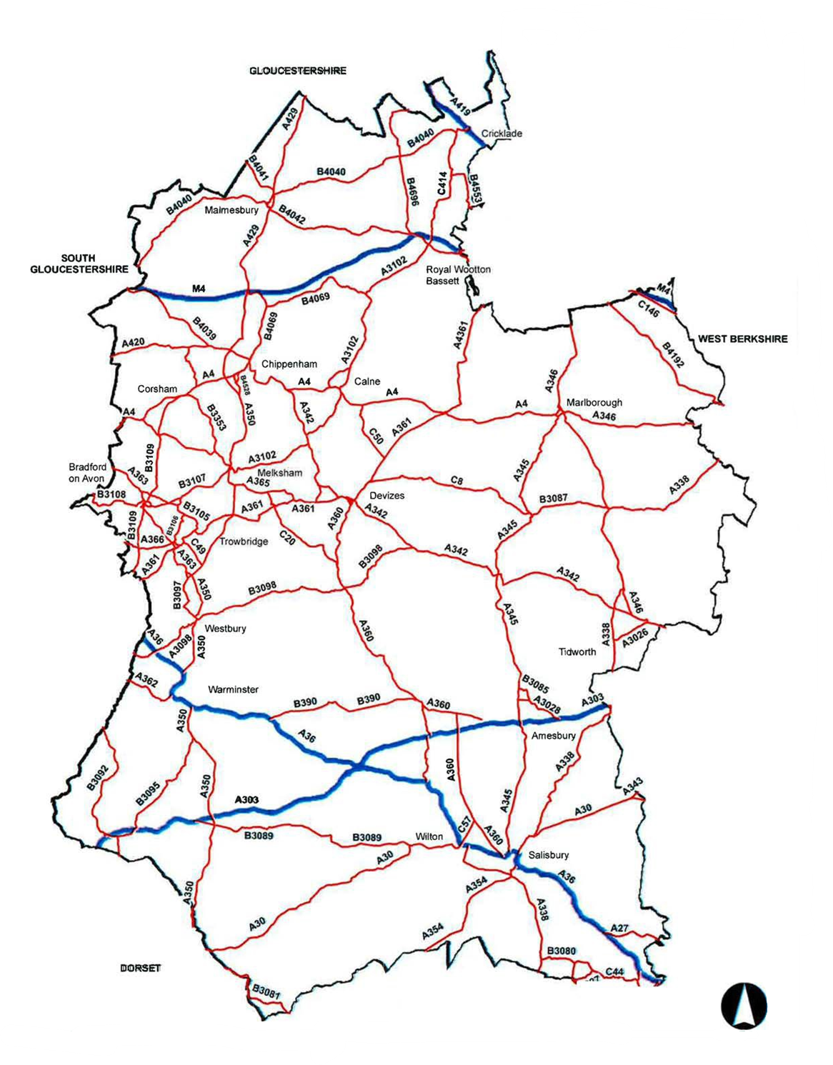

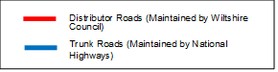

Frequently Asked Questions

1. What if my facilities or signs are located outside the Wiltshire County boundary?

If an application for tourism signs requires signing on routes in a neighbouring county, a separate application must be submitted to that local authority. That application will be assessed independently by that body according to its own policy for tourism signs, and applicants will be responsible for any costs incurred. See page 2 for information about applications for signs located in the area covered by Swindon Borough Council.

2. What if I want tourism signs on a motorway or trunk road?

If your attraction or facility lies on a trunk road or requires signs from a motorway or trunk road it will be necessary to involve National Highways. You will be advised if this is the case when your application is received by VisitWiltshire, although you should be able to identify if this is likely from the map in Appendix 4.

The Trunk Roads in Wiltshire are as follows: M4, A36, A303 and A419.

National Highways has special eligibility criteria, in addition to those listed in Appendix 1. Please refer to Apply for brown tourist signs on roads that Highways England manage - GOV.UK.

3. If my application is approved, what happens next?

It is a condition of approval for tourism signs that all existing advertising signs at or near the location of the new signs be removed prior to the signs being installed. This includes A-frame signs, blackboards, menu boards, 'open' or special offers signs, etc.

After this has been done (if necessary), the supply and erection of signs will be carried out by the appropriate highway authority.

